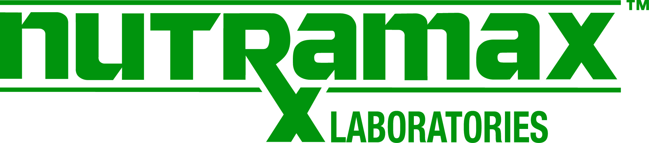

Nutramax Laboratories Job Description

Job Title: Maintenance Tech I | Reports to : Facility Manager
Department: Facilities/Maintenance | Prepared by: Facility Manager
FLSA Status: Non-Exempt
Reviewed by: Facilities Manager | Date Reviewed: 6/2021

Summary of the Position: Provides mechanical support for manufacturing/packaging operations associated with the production of Nutramax’s quality products as well as facility maintenance
Roles and Responsibilities:
- Planning and organizing the mechanical steps required in the production of safe quality products
- Performing set-up and adjustments to manufacturing/packaging equipment to ensure assigned machines run at peak efficiency and operations are within the cGMP guidelines and SOPs
- Maintaining and repairing all mechanical equipment pertaining to production, including but not limited to, filling, packaging and manufacturing equipment, in accordance with cGMP procedures
- Performing general facilitiy maintenance such as plumbing, HVAC and electrical
- Interacting with external vendors or contractors for services associated with the mechanical operations of production equipment and facilities
- Maintaining spare parts inventory
- Adhering to all established Standard Operating Procedures and Safety Policies (i.e., lockout/tagout)
- Performing assigned preventive maintenance tasks for production equipment and facilities operations
- Training new employees on the maintenance of equipment, safety of equipment, SOPs and GMPs on an as needed basis
- Perform other assigned duties as may be required in meeting company objectives
- Regular attendance is required
- Communicate effectively with other departments within the organization and function within a team environment.

Minimum Requirements: Attention to detail and process analytical skills are required. Must have good interpersonal skills and the ability to interact with all staff levels. Additionally, this position is required to stand on a regular basis and use hands and arms to lift and reach. Must be able to lift/move packages and material weighing a minimum of 50 lbs.

Education and Experience This position requires a high school diploma or GED with a minimum of 3 years of experience as a mechanic in a GMP or Pharmaceutical environment

Supervisory Responsibilities: none

______________________________________
Employee Name (print)

______________________________________ ___________________
Employee Signature Date

______________________________________
Supervisor Name (print)

______________________________________ ___________________
Supervisor Signature Date

